### 

### Semester Two Examination, 2022

### Question/Answer booklet

# MATHEMATICS SPECIALIST

**UNITs 3&4**

## Section One:

## Calculator-free

|  |
| --- |
|  |

Your Name

Your Teacher’s Name

## Time allowed for this section

Reading time before commencing work: five minutes

Working time: fifty minutes

## Materials required/recommended for this section

***To be provided by the supervisor***

This Question/Answer booklet

Formula sheet

***To be provided by the candidate***

Standard items: pens (blue/black preferred), pencils (including coloured), sharpener, correction fluid/tape, eraser, ruler, highlighters

Special items: nil

## Important note to candidates

No other items may be taken into the examination room. It is **your** responsibility to ensure that you do not have any unauthorised material. If you have any unauthorised material with you, hand it to the supervisor **before** reading any further.

|  |  |  |  |  |  |
| --- | --- | --- | --- | --- | --- |
| Question | Mark | Max | Question | Mark | Max |
| 1 |  | 5 | 5 |  | 6 |
| 2 |  | 13 | 6 |  | 5 |
| 3 |  | 5 | 7 |  | 5 |
| 4 |  | 5 | 8 |  | 5 |

**Structure of this paper**

|  |  |  |  |  |  |
| --- | --- | --- | --- | --- | --- |
| Section | Number of questions available | Number of questions to be answered | Working time (minutes) | Marks available | Percentage of examination |
| Section One:  Calculator-free | 8 | 8 | 50 | 49 | 35 |
| Section Two:  Calculator-assumed | 11 | 11 | 100 | 97 | 65 |
|  |  |  |  | **Total** | 100 |

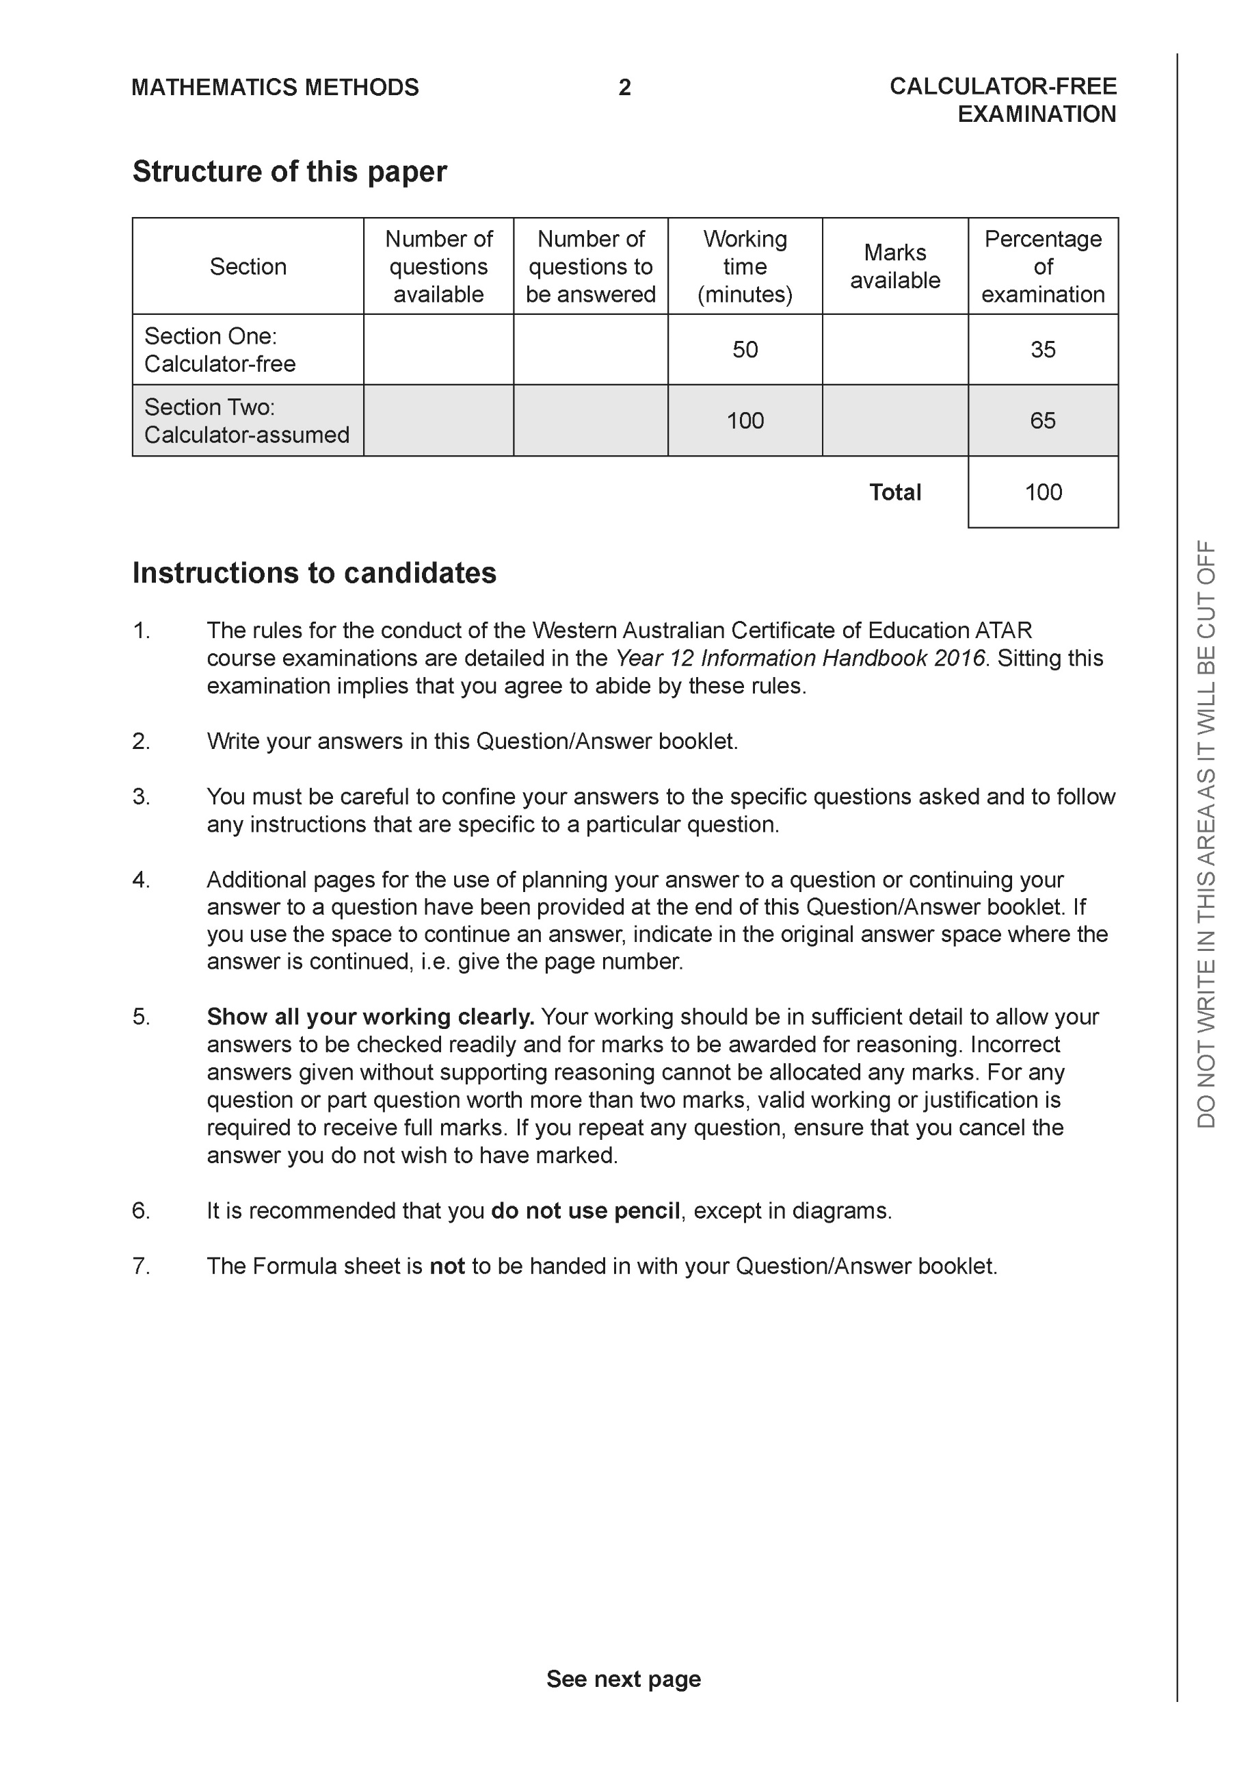

**Section One: Calculator-free (49 Marks)**

This section has 8 questions. Answer **all** questions. Write your answers in the spaces provided.

Spare pages are included at the end of this booklet. They can be used for planning your responses and/or as additional space if required to continue an answer.

● Planning: If you use the spare pages for planning, indicate this clearly at the top of the page.

● Continuing an answer: If you need to use the space to continue an answer, indicate in the original answer space where the answer is continued, i.e. give the page number. Fill in the number of the question that you are continuing to answer at the top of the page.

Working time: 50 minutes.

**Question 1 (5 marks)**

Consider the complex numbers  and  which are plotted below.

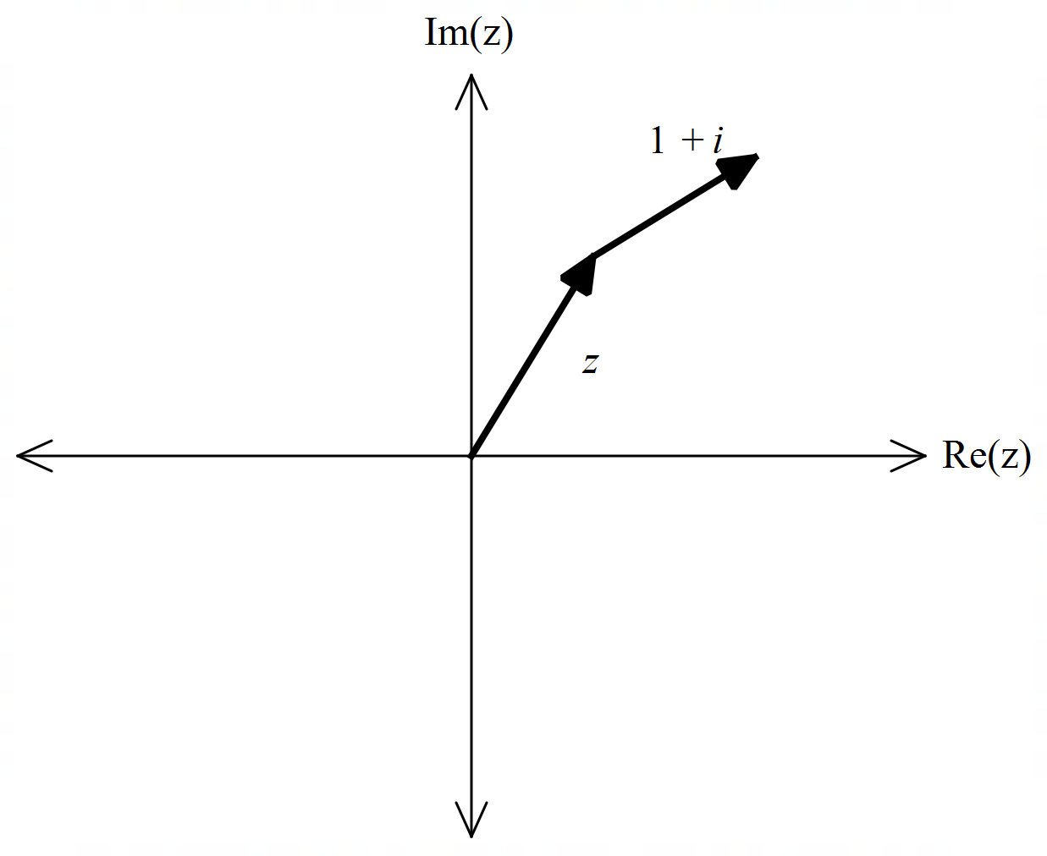

1. Express  in polar form. (1 mark)
2. Determine an exact expression for  . (4 marks)

**Q1 continued**

**Question 2 (13 marks)**

Consider the two functions  as shown below.

|  |  |
| --- | --- |
|  |  |

1. Sketch the inverse of  on the same set of axes. (2 marks)
2. Explain why  does not have an inverse. (1 mark)

The defining rule for  is as follows 

1. Determine the rule for  and state its domain. (3 marks)

Q2 continued

1. Determine . (2 marks)
2. Does  exist for all values of the natural domain of ? Explain. (2 marks)
3. Determine the domain and range of . Justify. (3 marks)

**Question 3 (5 marks)**

Using an appropriate substitution, determine the following integral .

**Question 4 (5 marks)**

Consider the function . Sketch the function on the axes below showing all asymptotes and major features.

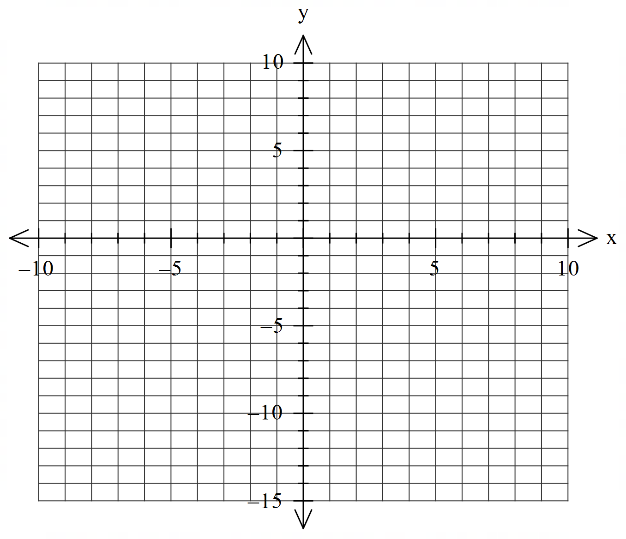

**Question 5 (6 marks)**

1. Given that  , determine the values of the constants . (3 marks)
2. Hence determine   and express answer as one log term. (3 marks)

**Question 6 (5 marks)**

Consider the polynomial  with .

1. Determine a quadratic factor of . (2 marks)
2. Hence solve the equation  (3 marks)

**Question 7 (5 marks)**

By using  and De Moivre’s theorem, determine exact values for .

**Question 8 (5 marks)**

Determine the indefinite integral  showing full working.

Working out space